**How to use Aeries Browser Interface to take classroom attendance.**

**Start Internet Explorer and open** [**http://aeriesabi**](http://aeriesabi)**. You can simply enter aeriesabi and hit the enter key. Enter your username which is your normal network login username. For password enter welcome (all lower case) the first time. Choose your school in the dropdown if it is not already displayed and click the Log In button.**

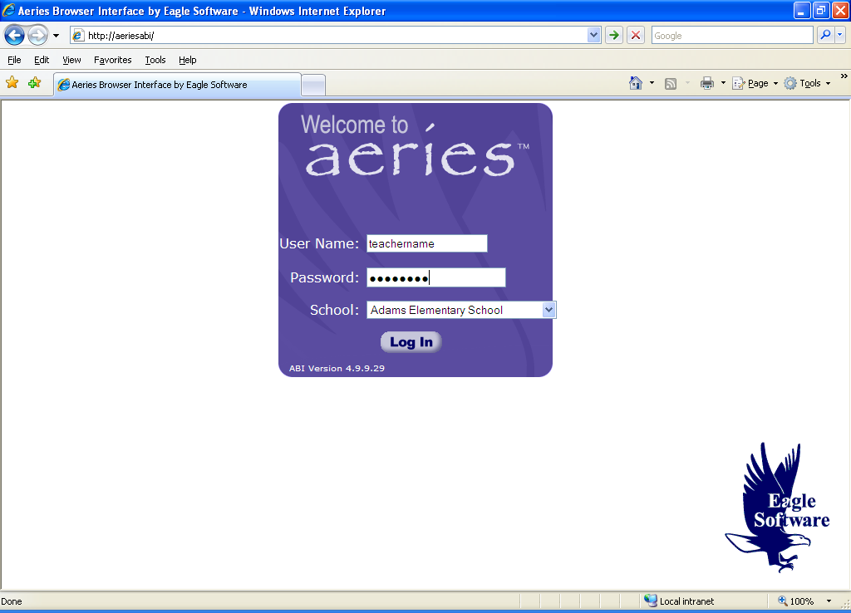

**Once you have logged into the system you will be prompted to change your password. Enter your old password welcome and then enter a secure password of your choice and confirm the password by typing it again. This does not have to be your normal network login password.**

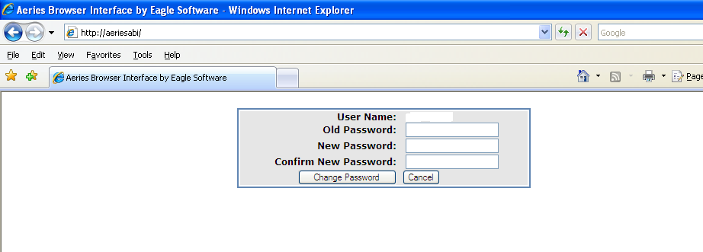

**You are now logged into the system and can take attendance. Click on the Attendance menu item which allows you to choose to 1) Take Attendance, 2) Take Attendance by Photo (if photos are available), 3) Build a Seating Chart or 4) Generate Reports. This is illustrated in the following screen shots.**

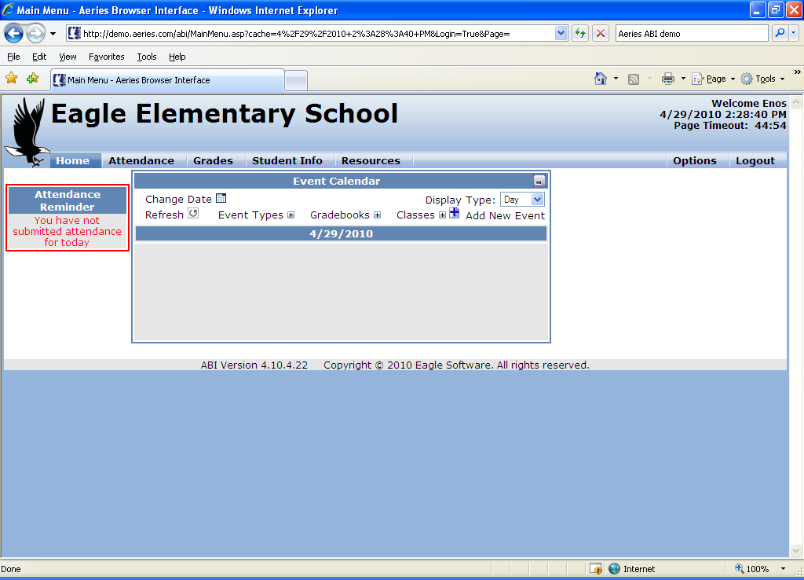

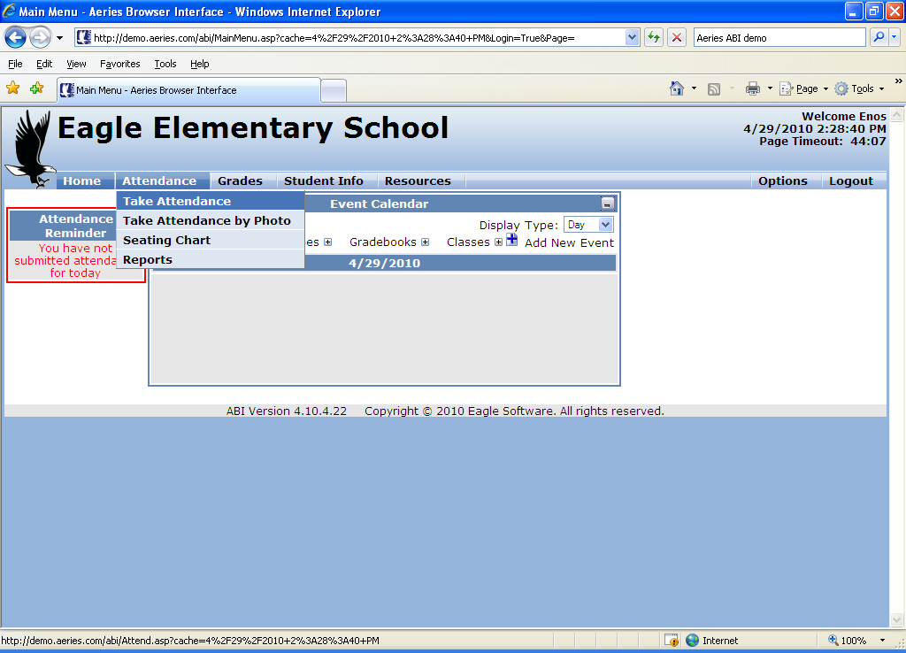

**The following screen is the result of selecting the first Take Attendance choice under the Attendance menu item. Since photos will not be available initially you may elect to use this screen.**

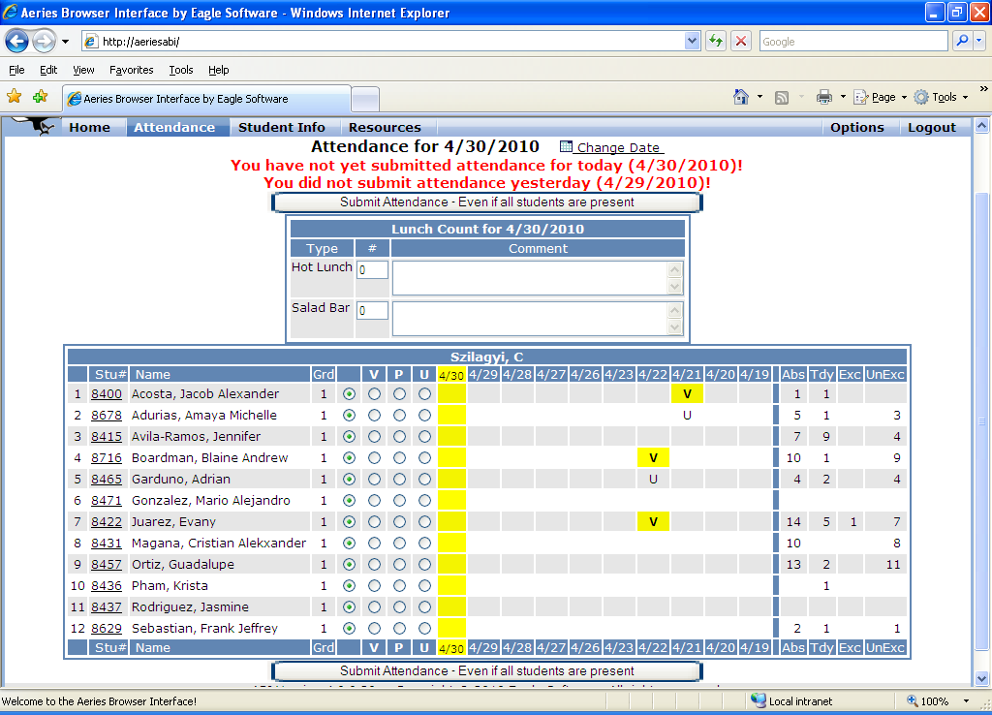

**Simply go down the list and click the radio button V for absent or U for Tardy. Select P if you accidentally counted a student absent or tardy by mistake. Note that the student is highlighted once you enter attendance data.**

**To submit attendance, click the Submit Attendance button (it is at the top and bottom of the screen – you can click either one.**

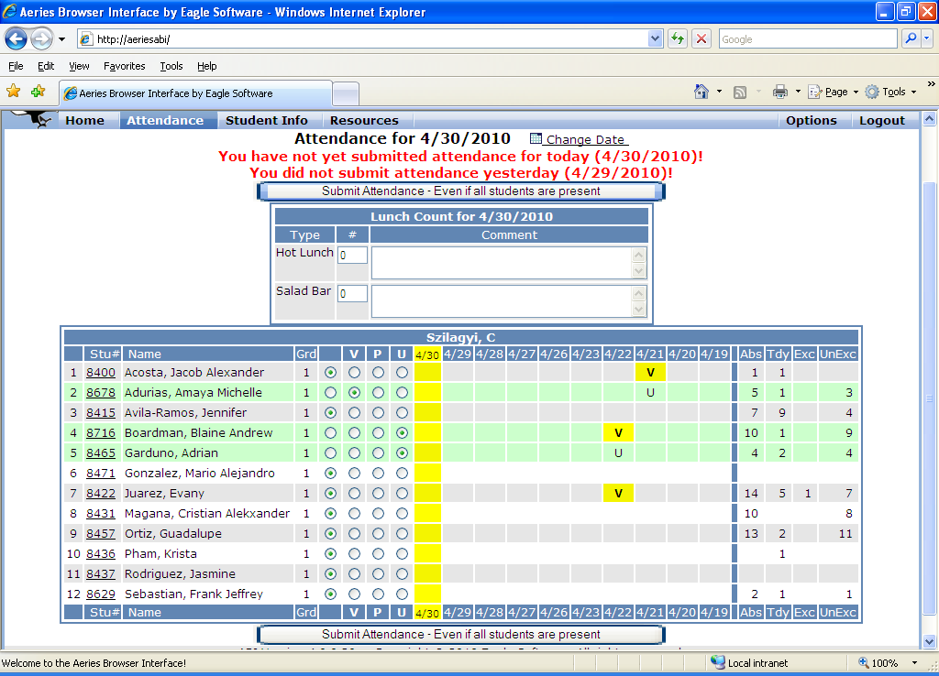

**After attendance has been taken select the Logout menu item on the top left of the screen next to Options. Do not leave your computer unattended. The system will time you out after 20 minutes if you have not entered anything.**

**Certification of Attendance Recording**

**To review and certify the attendance you recorded, after all attendance has been submitted for the week, typically late in the day on Friday of each week, print the “Weekly Attendance Report”.**

**Under “Reports”, select “Weekly Attendance Report”**

**Review and verify your recorded attendance, sign and date the form and submit it to your School’s Attendance Office no later than Monday of the following week.**

